

Media database

John Michael Pasiolan, Andrew Shahini, Danat Muradov



November 29, 2024

Application development

Vanier College

Table of Contents

Project Description 1

UML Diagram 2

Program Features and Screenshots 3

Functionalities 3

Expected Output 3

Login Form 4

Description: 4

Features: 5

Create Account Form 5

Description: 5

Features: 5

Payment Form 6

Description: 7

Features: 7

Profile Form 8

Description: 8

Features: 8

Challenges 10

Learning Outcomes 11

# Project Description

Our project is a movie system that allows the user to sign in as a client to search through a database of films. The system will allow the user to create an account and pay for a premium membership or keep the regular membership. The premium membership will have access to the recommendation engine that generates movies that seem appealing for the user in reference to their search history and their preferences. Premium members will also be able to view the best actors around the world and can comment on their performance as many times as they want to. In contrast, the regular membership has a limit of 5 comments on their account just for movies and Tv shows. In addition, the interface will allow the client to search for their favourite movies based on the directors, actors, genre, and title. Our project will also allow the client to add movies to their watchlist, see the reviews that movie critiques leave on the film. Furthermore, the user can leave their own review on the different media, actors and even directors by giving it a rating and comment.

# UML Diagram

# Program Features and Screenshots

## Functionalities

* Fetching and filtering movie information such as title, genre, rating, director, and actors from the movie database.
* Add movies to the user’s watchlist.
* The user can rate and review media, which are stored in the database.
* Premium members can give a rating to the actors and directors of their choice.
* Recommendation engine that generates after the user’s search history and their watchlist.
* The user has to create an account and log in to our system.
* The user can upgrade their membership to premium by paying online.
* The user interface can be provided in English and French.
* Making a payment to upgrade the user’s membership

## Expected Output

* The interface should be displayed in English or in French based on the user’s choice.
* The login page should be refused if the user does not have an account and granted if they do have an account.
* The interface will update the user’s watchlist after adding or removing a movie.
* The interface will match the search or filter and return a list of movies.
* Details about a specific movie.
* Regular members can upgrade their membership to premium to get access to the recommendation engine based on the user’s activity preferences.
* Adding and fetching movie ratings and reviews from the database.
* Display a top 10 list of the best movies, tv shows, actors, and directors for the premium members.

## Login Form

### Description:

In the Login form, you can log in into your account if you already have one. If you don’t you can click on the Create Account button to create an account.

### Features:

* + Language button that allows you to switch language. It will make all the words in the form turn into French.
  + Login button that allows you to login into your existing account.
  + Create Account button that allows you to create a new account, if you do not already have one

## Create Account Form

### Description:

You can create your new account in the Create Account Form. Choose between Regular and Premium memberships. Depending on which membership you pick, you will either pay for the premium or it will automatically be made if you pick the regular version.

### Features:

* + Language button that allows you to switch language. It will make all the words in the form turn into French.
  + Back button that allows you to go back to the previous form (Login Form)
  + Show Password checkbox that allows you to see the password when it is checked.
  + Date Box to choose your birthday accurately.
  + Pay button that will bring you to the payment form to pay for your premium Account
  + Create Account that will bring you to the main menu form.

## Payment Form

### Description:

If you have chosen the premium membership in the create account form, it will bring you to the payment form. In the payment form, you get to pay for the membership by putting in the your card information in the available boxes..

### Features:

* + A pay button. When clicked, it validates your card, and once it has been verified and everything is all good, it will pay.
  + -When clicked, the back button returns you to the create account form. So, if you ever change your mind, the back button is always available.

## Profile Form

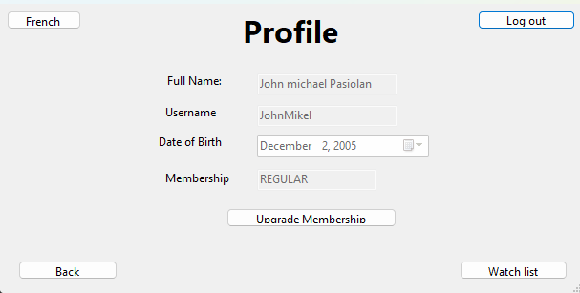

### Description:

The Profile Form is straightforward. It allows you you view your profile details, so your full name, username, date of birth, and membership. You can always upgrade your membership whenever you want, and you can view your personal watchlist.

### Features:

* + Language button, so you can switch to English or French.
  + A logout button, so you can log out of your account whenever.
  + An upgrade membership button, for when you want to purchase the premium version of the membership to access more features.
  + A back button to return to the main menu.
  + A watch list button, to view your watch list.

# Challenges

# Learning Outcomes